Cell Line: H129-1
Catalogue Number: 14040203

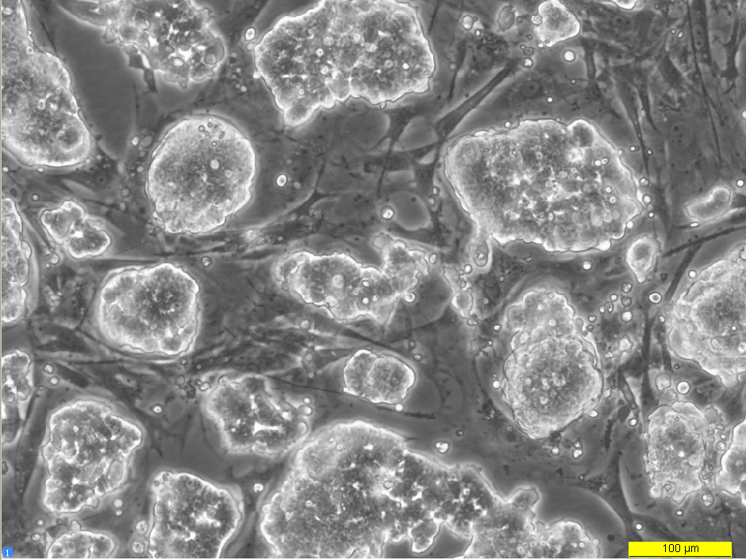
72 hours post resuscitation

