Images for Cell Line: Hela-Mitotrap

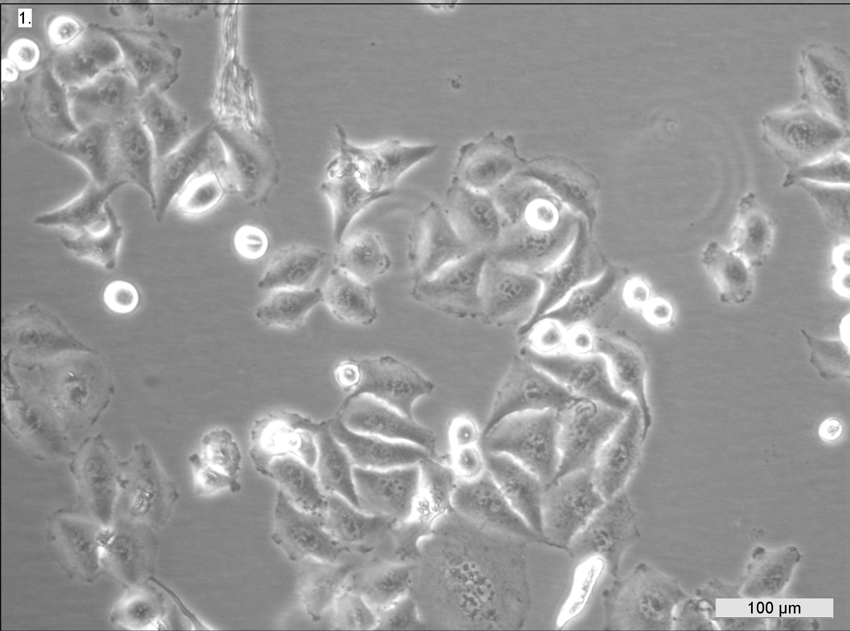
ECACC 15042201 Hela-Mitotrap Early log-phase
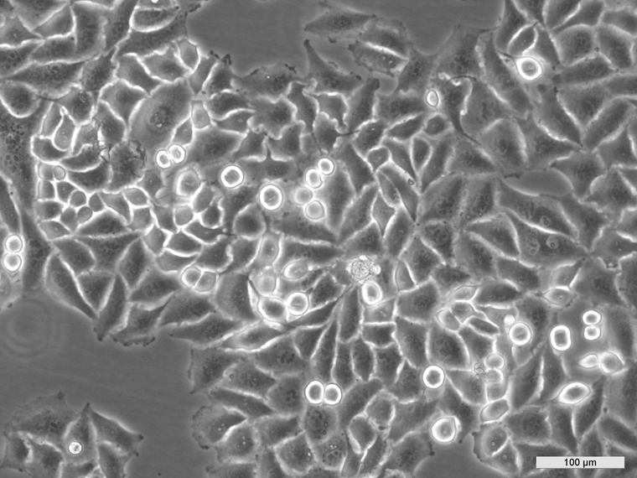
ECACC 15042201 Hela-Mitotrap Mid log-phase

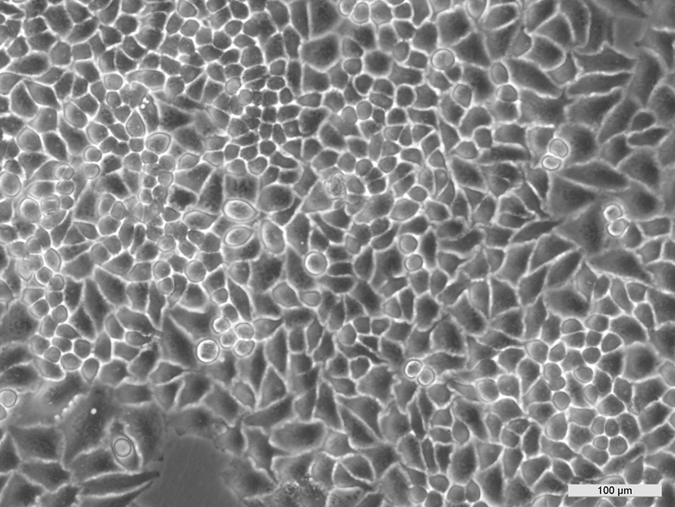
ECACC 15042201 Hela-Mitotrap Late log-phase

