Images for Cell Line: Hela-Mitotrap-Ap1g1-FKBP

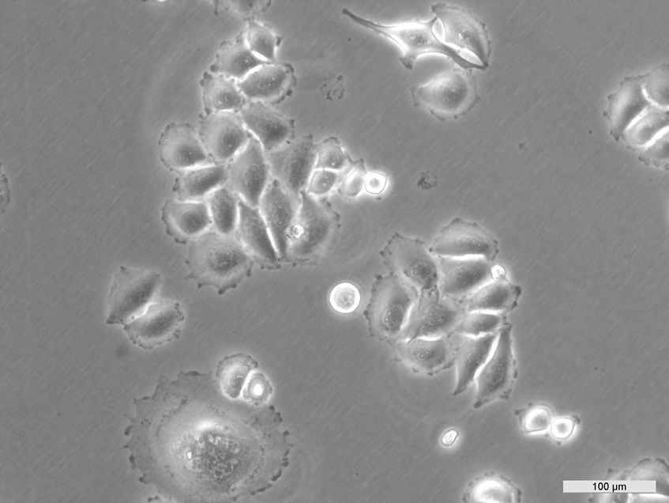
15042203 Hela-Mitotrap-Ap1g1-FKBP Early log-phase
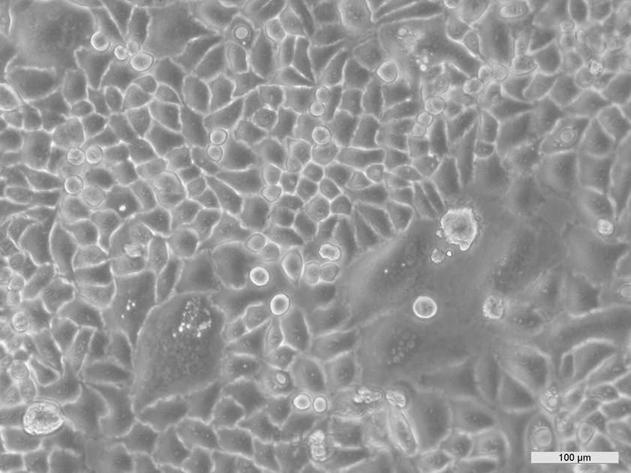
15042203 Hela-Mitotrap-Ap1g1-FKBP Late log-phase

