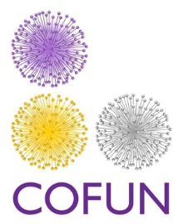

Handling Strains from the Transcription Factor Knock-Out Library

Brief instructions on handling strains from the TF KO library.
The TFKO library is shipped in 50ul aliquots in 96 well plates. The strain identifiers are given in file COFUN004. All strains have been generated according to the overview document COFUN001. All knockout mutants have been purified by selection on hygromycin in SAB agar (Thermo Scientific CM0041 ) at 200 mg/L.
We would strongly suggest that before you use the isolates that you streak each strain to purity. Although we take all efforts here to avoid contamination working with large numbers of strains can be a challenge and we cannot absolutely guarantee that there has been no cross contamination.

Streaking strains to purity:
We would suggest that for each strain, a streak plate is prepared by plating 1µl of each spore stock on a selective plate (either SAB or any other suitable complete media; e.g. Aspergillus complete media) containing hygromycin at 200 mg/L. Incubate for 48 hours at 37˚C. Take conidia from a single colony and inoculate a small (12.5 cm²) tissue culture flask (must have a vented cap) with SAB or your complete media of choice containing hygromycin at 200 mg/L. Incubate for 3-5 days at 37˚C. Harvest spores into PBS containing 0.01% tween20. For long term storage, strains should be stored in solution containing glycerol (minimum 10%) at -80 ˚C.

Notes on strain validation:
Strains have been validated according to the process outlined in COFUN003. For the avoidance of doubt, single copy integration has not been verified by Southern blot. We strongly advise that the validity of any strains you work on is verified using your internal methods. The sequences of the primers used to generate the knockout cassettes are given in COFUN002 for your information.

