Cell Line: ULK1(-/-), ULK2(-/-), DKO (SIM)
Catalogue Number: 14050803
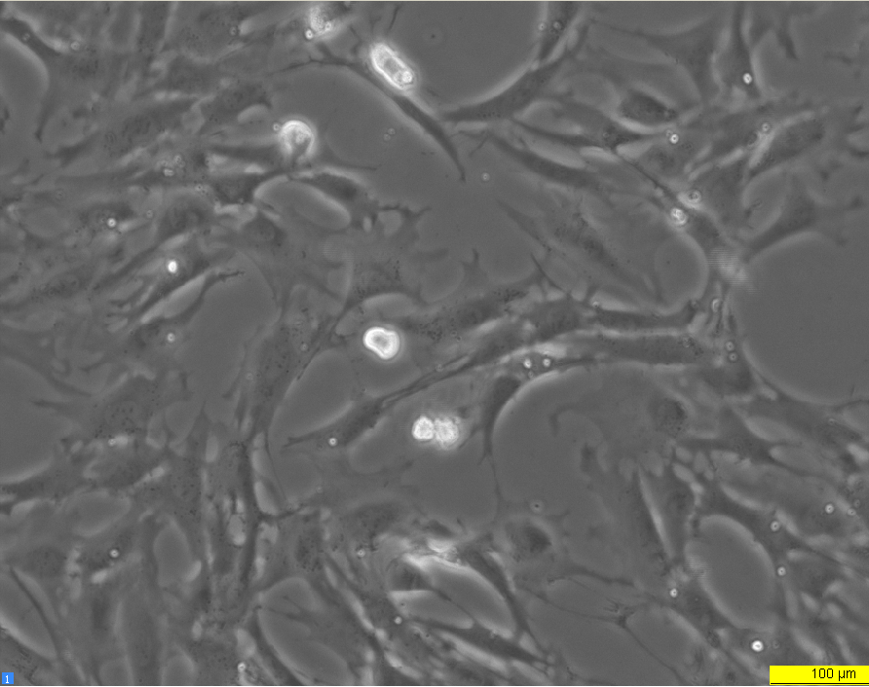
Early log phase 24 hours

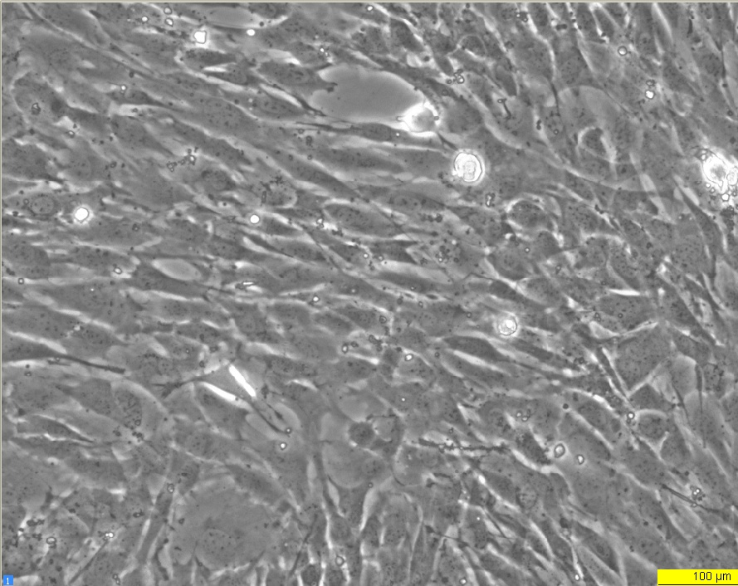
Late log phase 72 hours

