Cell Line: ULK1 KO MEF (SIM)
Catalogue Number: 14050806
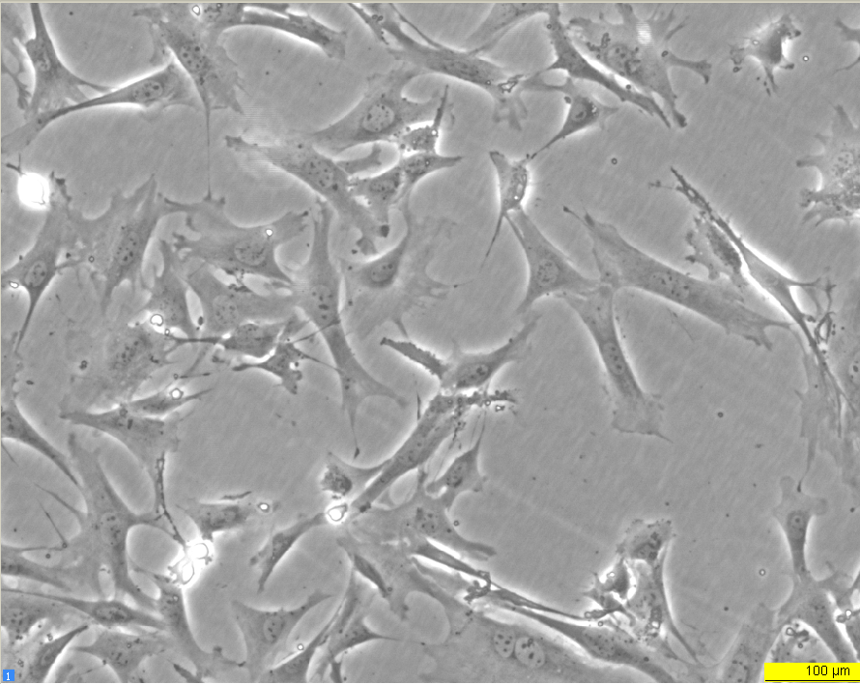
Early log phase 24 hours
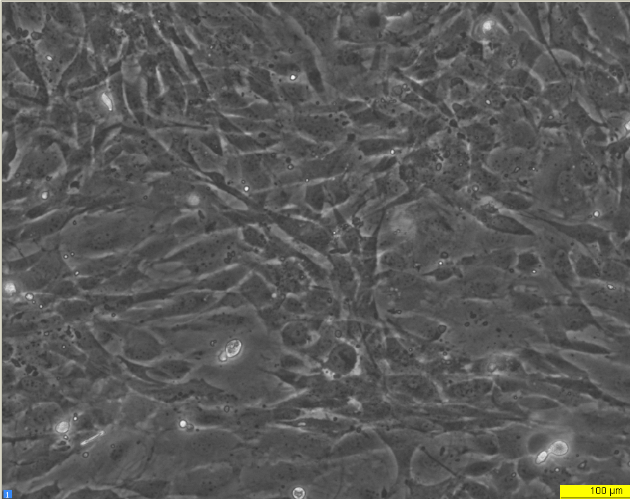
2.78002e-0072.78002e-00714I002_00002.jpg0;1823701;0;1;0;00;00;0ims_phe_ecacc(ims-Server)88E2FA246DD2F5734018EB18FAA0CB6A_326194425920;1;10;0;00;0;0;0;302.211;226.8
Late log phase 72 hours

