Cell Line: ULK2 KO MEF (SV40)
Catalogue Number: 15050805
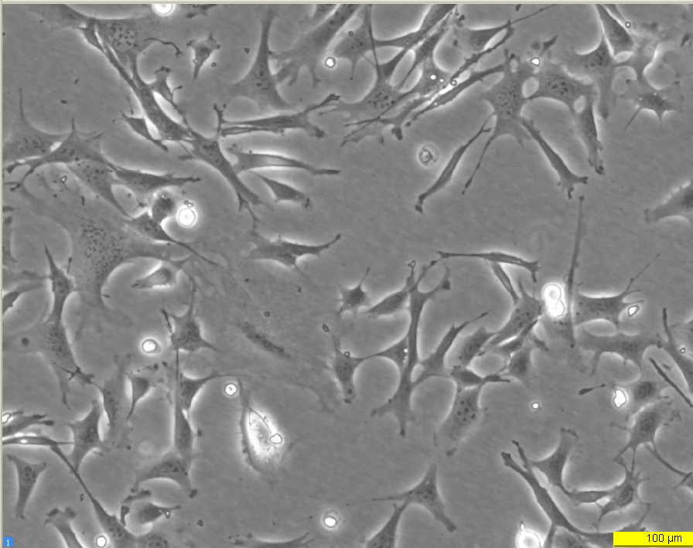
Early log phase 24 hours
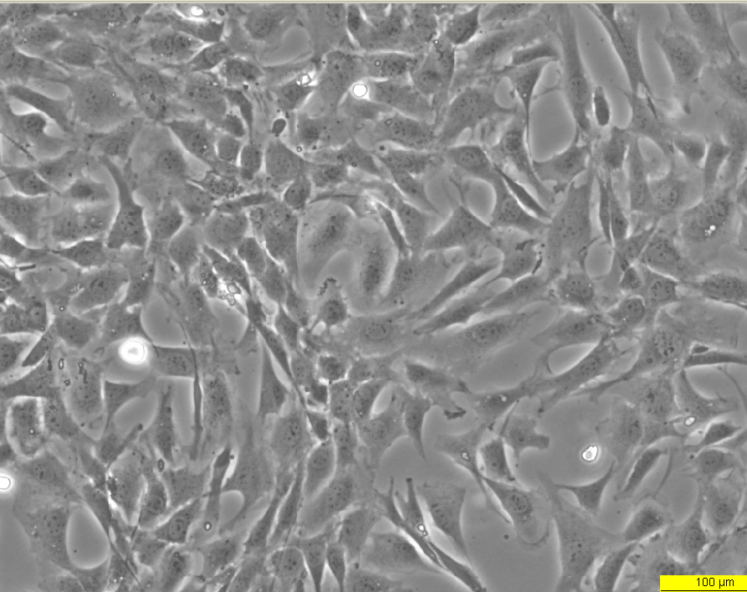
Late log phase 72 hours

