Cell Line: ULK1/2 WT MEF (SIM)
Catalogue Number: 14050808
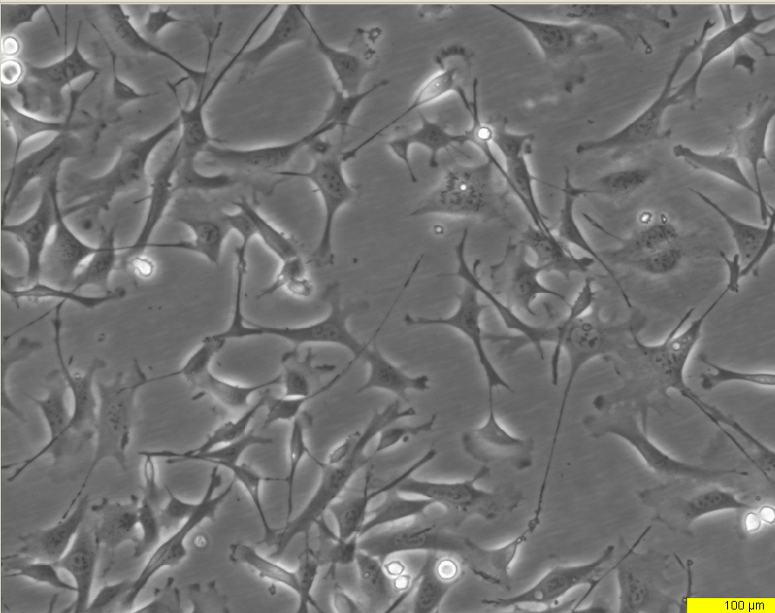
Early log phase 24hrs
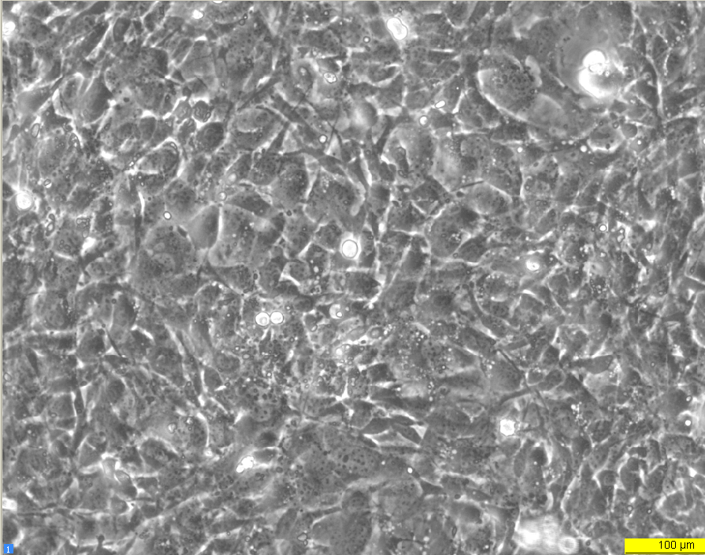
Late log phase 72hrs

