Cell Line: ULK2 KO MEF (SIM)
Catalogue Number: 14050810
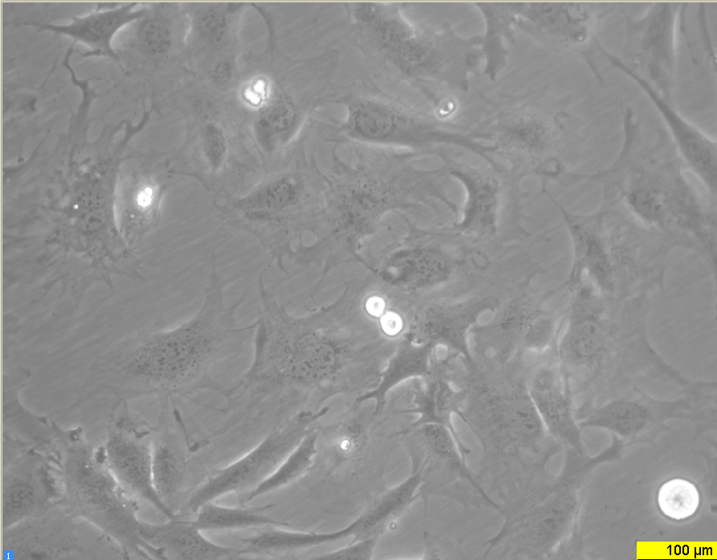
Early log phase 24 hours
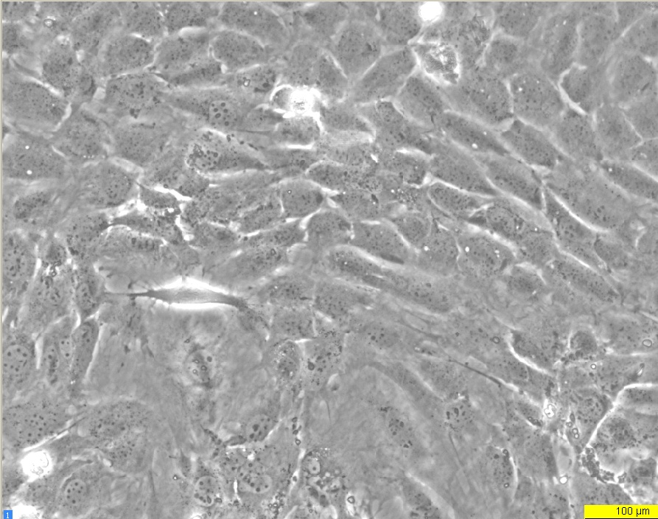
Late log phase 72 hours

